On windows node

Step:1 Click On Go to security configuration screen and change it

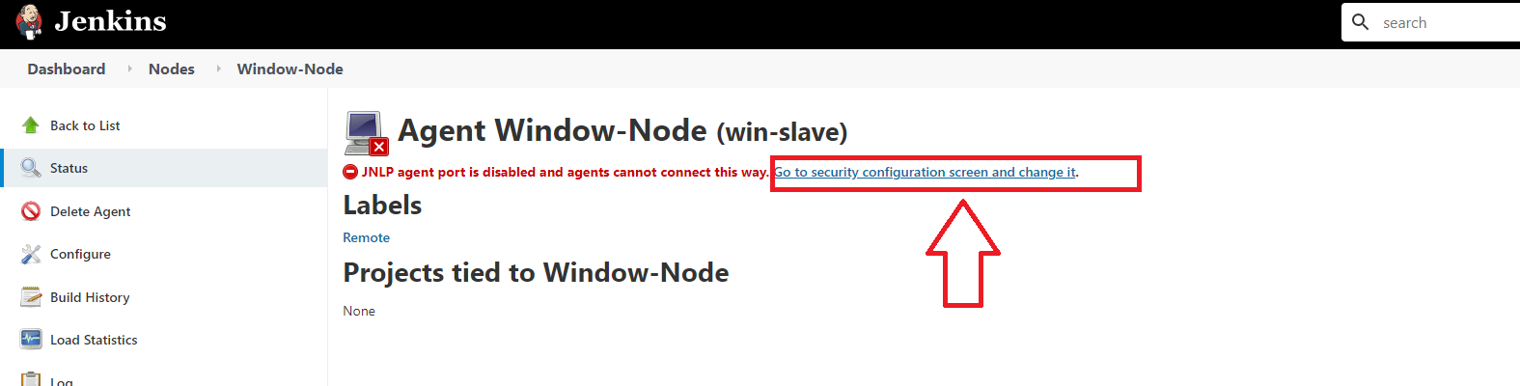

Step:2 Scroll Down To Agents And Select Random

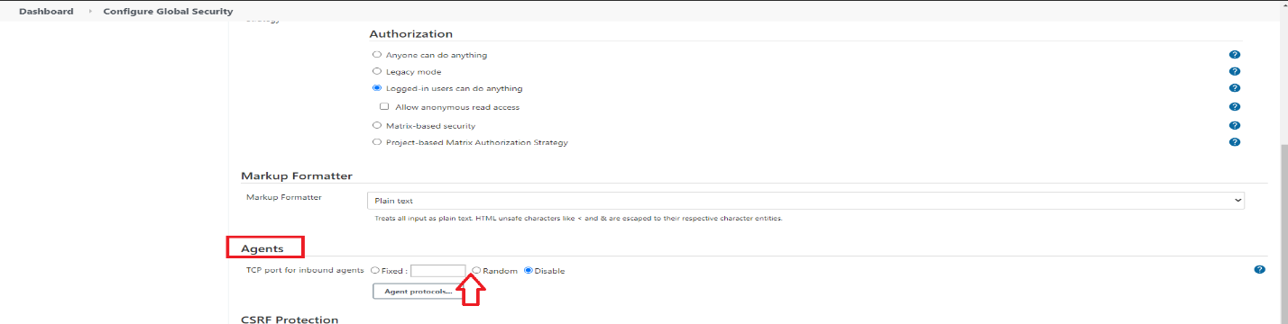

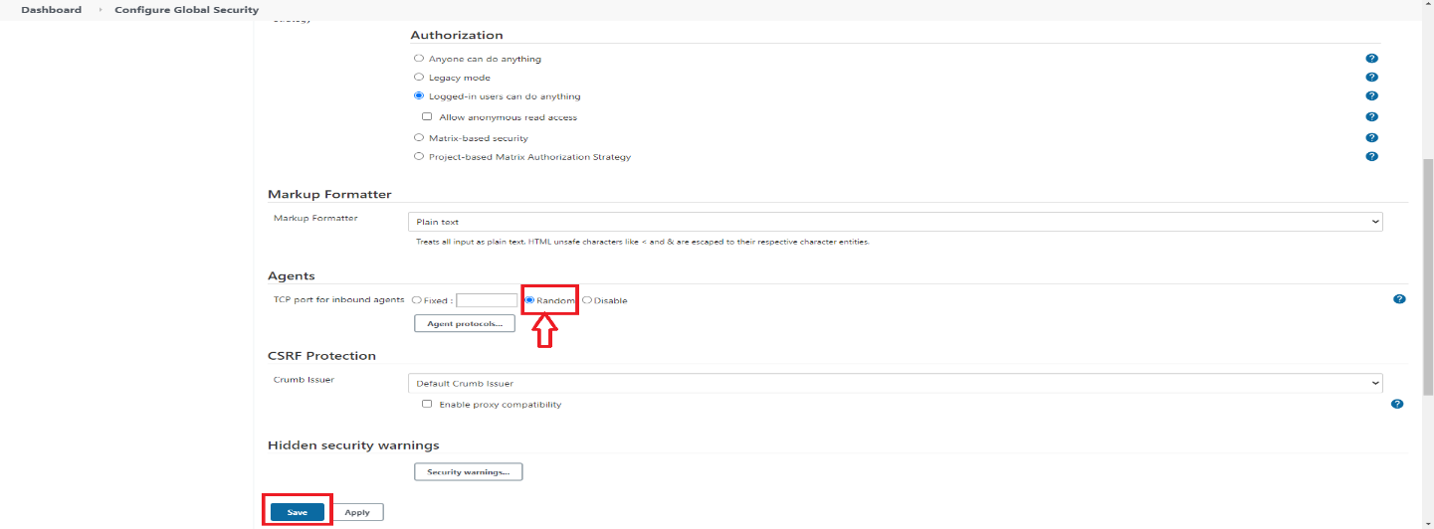

Step:3 Click On Windows-Node On Left

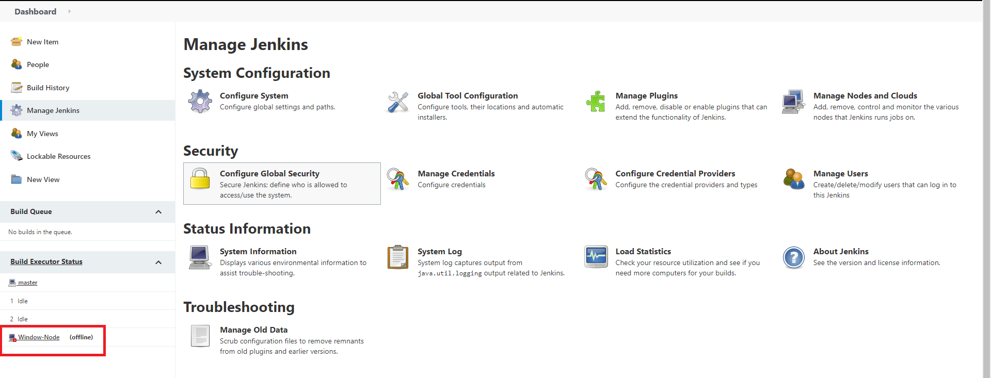

Step:4 Click On Launch

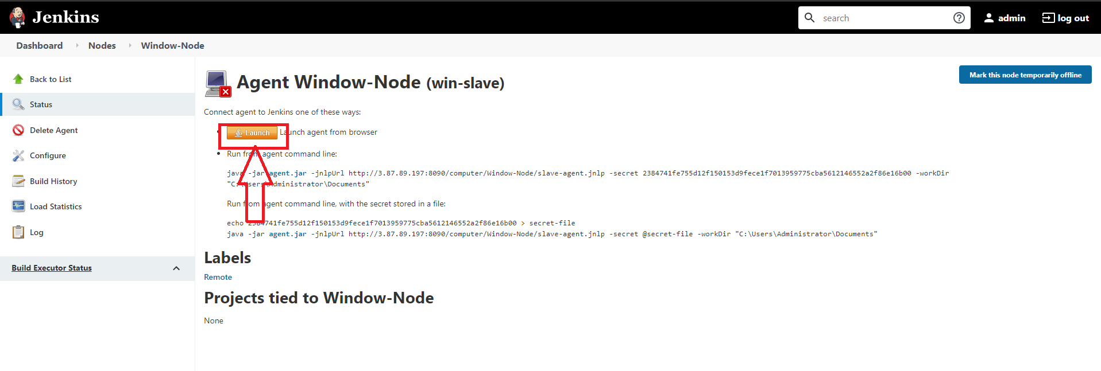

Step:5 A File Will Be Auto Downloaded Click On Keep

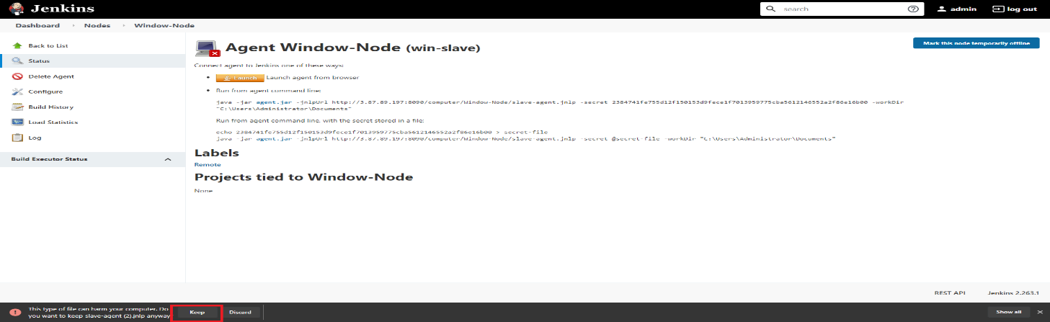

Step:6 Copy The File And Paste It On Windows Node Server Desktop

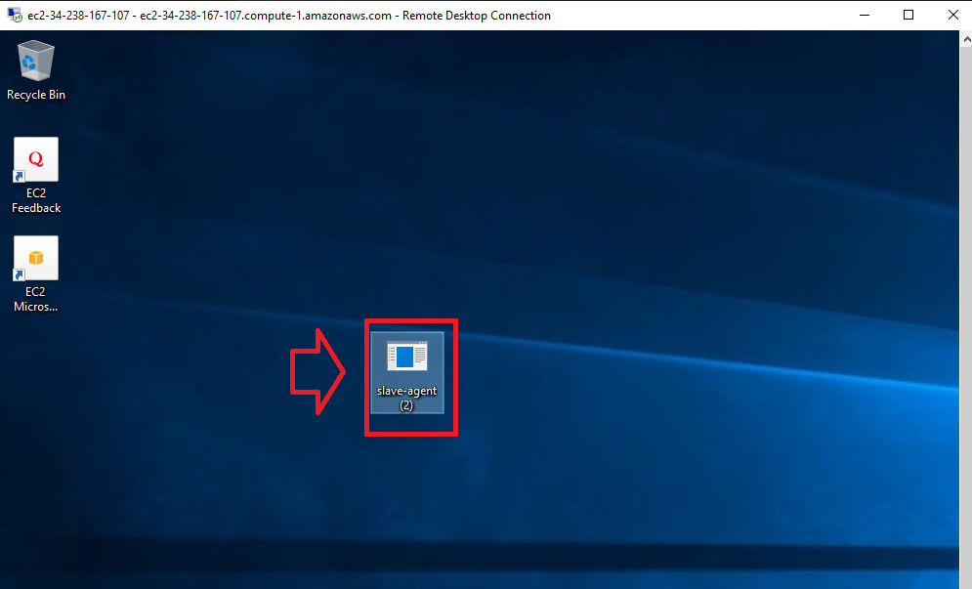

Step:7 Run ThIs File

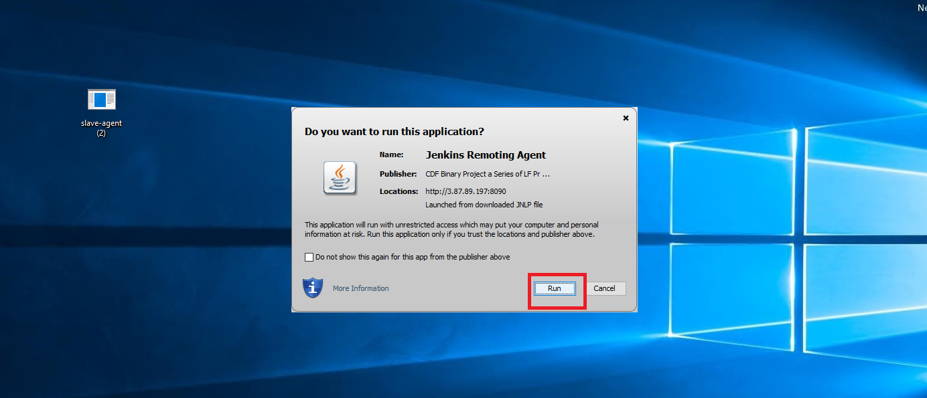

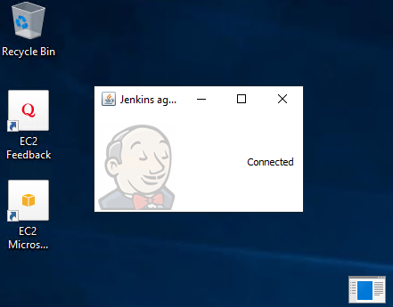

Step:8 Go To Jenkins And Check The Status

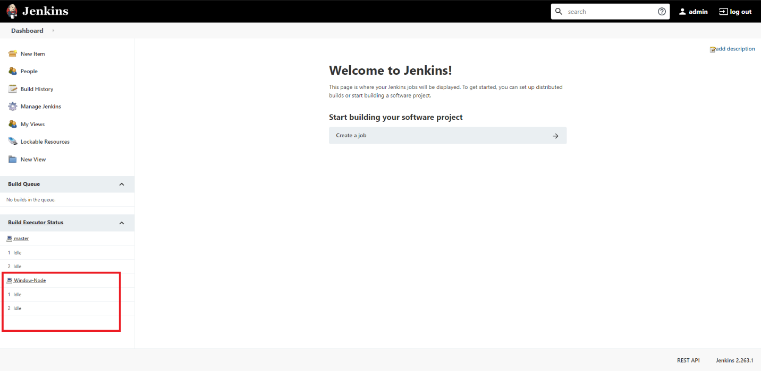

-----------------------------------------End Of Adding Windows Node (B)------------------------------------